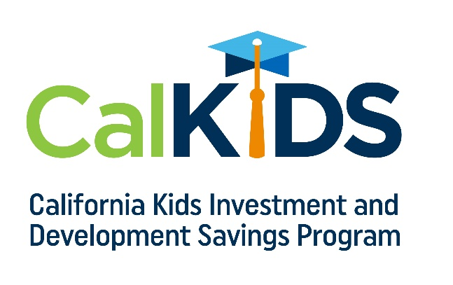

EMAIL 1 – Parents of Newborns + Young Children

SUBJECT: Your child may have their first scholarship waiting right now!

All children born in California on or after July 1, 2022 have been awarded a CalKIDS Scholarship worth up to $175, parents just need to claim them.

Claiming a CalKIDS Scholarship is quick and easy.

Step 1: Find your child’s birth certificate and locate the Local Registration Number (LRN) on it.

Step 2: Visit CalKIDS.org and click “Claim Scholarship”

Step 3: Enter the county where the child was born, their birthdate, and their LRN.

Step 4: Create a user profile.

College may feel far off, but when parents claim their child’s CalKIDS Scholarship, the money can grow over time with their child. And, when the time comes to pay for higher education expenses like tuition, books, supplies, or a laptop, their CalKIDS Scholarship can help make a big difference.

Head over to CalKIDS.org today!

[NAME]
[TITLE]

To learn more about CalKIDS, including eligibility and scholarship amounts, visit CalKIDS.org

EMAIL 2 – Parents of Students

SUBJECT: Your child may have a CalKIDS Scholarship worth at least $500!
As a California public school student, your child may have already been awarded a CalKIDS Scholarship worth at least $500. All you need to do is claim it. These scholarships are part of a $2 billion dollar investment from the state of California to help more than 5 million children pursue college or career training.
Checking to see if your child has a CalKIDS Scholarship is quick and easy.
Step 1: Locate your child’s Statewide Student Identifier (SSID), which can be found [INSERT WHERE YOUR STUDENTS CAN LOCATE THEIR SSID].
Step 2: Visit CalKIDS.org and click “Confirm Eligibility.”
Step 3: Enter your child’s SSID.
You will find out instantly if your child was awarded a CalKIDS Scholarship, and it takes just a few minutes to claim it.
This is real money, no strings attached. See if your child has a CalKIDS Scholarship waiting for them, and claim it now so that the money is available when the time comes to cover those college or career training expenses.
Take your child’s SSID to CalKIDS.org today!

[NAME]
[TITLE]
To learn more about CalKIDS, including eligibility and scholarship amounts, visit CalKIDS.org

EMAIL 3 – High School Students

SUBJECT: You may have a CalKIDS Scholarship worth at least $500!

As a California public school student, you may have already been awarded a CalKIDS Scholarship worth at least $500. All you need to do is claim it. These scholarships are part of a $2 billion dollar investment from the state of California to help more than 5 million kids pursue college or career training.

Checking to see if you have a CalKIDS Scholarship is quick and easy.

Step 1: Locate your Statewide Student Identifier (SSID), which can be found [INSERT WHERE YOUR STUDENTS CAN LOCATE THEIR SSID].

Step 2: Visit CalKIDS.org and click “Confirm Eligibility.”

Step 3: Enter your SSID.

You will find out instantly if you have a CalKIDS Scholarship, and it takes just a few minutes to claim it.

This is real money, no strings attached. See if you have a CalKIDS Scholarship waiting for you, and claim it now so that the money is available when the time comes to cover those college or career training expenses.

Take your SSID to CalKIDS.org today!

[NAME]
[TITLE]

To learn more about CalKIDS, including eligibility and scholarship amounts, visit CalKIDS.org

