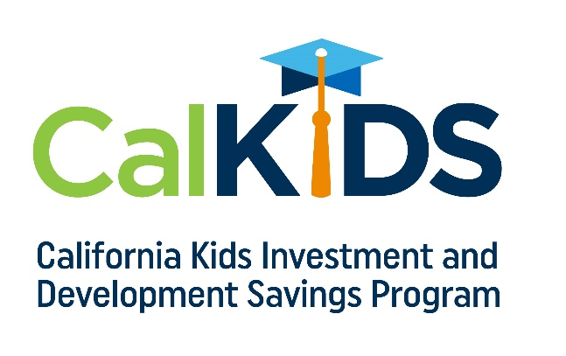

Script:
Please deliver key points in your personal tone and style.
Audience: Primarily students

Hi everyone,

Did you know California funded a free college savings account for eligible students?

CalKIDS is a program from the State of California that funds up to $1,500 in free money for eligible public school students to save for college and career training.

Visit CalKIDS.org to check if you’re eligible and claim your account.

