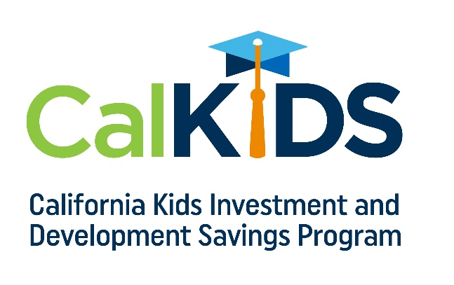

Month/Date/Year
CalKIDS Email / Newsletter Template
Audience – School Parents
Subject: Money for College – Your Child May Be Eligible for $500 or more
As a California public school student, your child may be eligible to receive $500 to $1,500 for future higher education expenses. Funded by the State of California, funds in your California Kids Investment and Development Savings Program (CalKIDS) account can be used for a variety of qualified higher education expenses, such as tuition, books, computer equipment and certain room and board expenses. Checking your eligibility and claiming funds in your CalKIDS account is easy. All you need is your child’s 10-digit Statewide Student Identifier (SSID), which can be found (school to insert how it can be found).
For more information and to check your eligibility, visit CalKIDS.org.

*Student eligibility is defined by the Local Control Funding Formula.
The California Kids Investment and Development Savings Program (CalKIDS) is a children’s savings account program, administered by the ScholarShare Investment Board, an agency of the State of California. CalKIDS will provide eligible participants with college savings accounts, including seed deposits and other potential incentives, to help pay for future qualified higher education expenses. To learn more about CalKIDS or opt out of the program entirely, please see the Program Information Guide at CalKIDS.org. CalKIDS participants may also establish individual accounts with ScholarShare 529, California’s 529 College Savings Plan.

