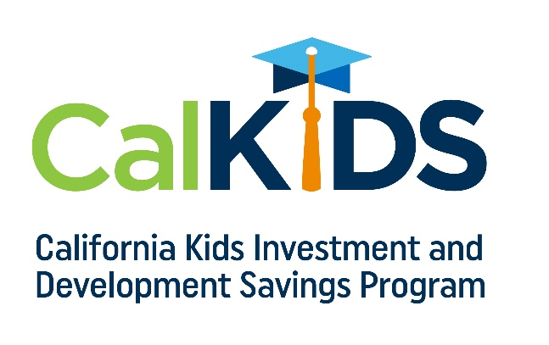

CalKIDS is a children’s savings account program administered by the ScholarShare Investment Board, an agency of the State of California. CalKIDS will provide each child born in California and eligible low-income public school students with up to $1,500 for college and career training.

There are two eligible groups for this program with unique benefits.

Up to $1,500 for 3.6 Million Eligible California Students:*

- $500 Automatic Deposit: Eligible low-income public school students.
- $500 Additional Deposit: Eligible low-income public school students identified as foster youth.
- $500 Additional Deposit: Eligible low-income public school students identified as homeless.

Up to $175 for Newborns:
- $25 or $100 Automatic Deposit: Every eligible child born between July 1, 2022 through June 30, 2023 receives $25. As a result of additional funding, babies born after July 1, 2023 receive $100.
- $25 Additional Deposit: Those who register on the program’s online portal.
- $50 Additional Deposit: Those who link a new or existing ScholarShare 529 account to their CalKIDS account.

Visit www.calkids.org to see if your child is eligible and claim your account.

* Student eligibility is defined by the Local Control Funding Formula.

