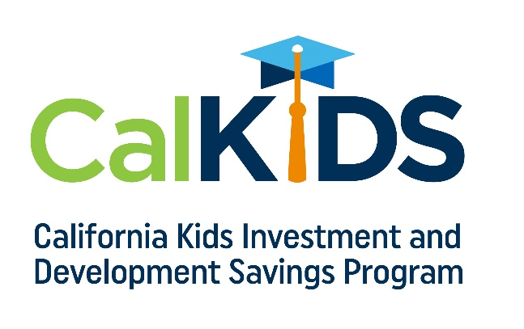

Month/Date/Year
CALKIDS COLLEGE SAVINGS PROGRAM

State Program Will Make College More Accessible for California Families

The California Kids Investment and Development Savings Program (CalKIDS), a program administered by the ScholarShare Investment Board, an agency of the State of California and chaired by the State Treasurer, automatically provided eligible, low-income public school children in grades 1-12 in California with the tools to start saving for college, including an initial seed deposit and possible financial incentives in a college savings account. The State of California created the program to expand access to higher education and encourage families to save for college and other forms of career training, regardless of household income.

"Financial concerns shouldn’t stand in the way of a college education for California families," said Julio Martinez, Executive Director of the ScholarShare Investment Board. “Research shows that children with $500 or less saved for college are three times more likely to enroll in college and four times more likely to graduate than children without college savings accounts. We want our students to feel supported and know that in California, we believe in the advantages of a higher education and the positive difference that could make in their lives.”

Students in grades 1-12 may receive up to $1,500 in college savings
The State of California offers eligible low-income public school students the following awards in a CalKIDS account to save for higher education, as applicable:*

- $500 initial deposit
- $500 additional deposit for students identified as foster youth
- $500 additional deposit for students identified as homeless youth

Over time, funds in a CalKIDS account can grow and be used for future higher education expenses, such as tuition and related fees, books and required supplies, and computer equipment. When the student is ready to use their savings to pay for any qualified higher education expense, they can easily redeem their funds, including any earnings, from their CalKIDS account.

To learn more about the program, visit CalKIDS.org.

* Student eligibility is defined by the Local Control Funding Formula.
The California Kids Investment and Development Savings Program (CalKIDS) is a children’s savings account program, administered by the ScholarShare Investment Board, an agency of the State of California. CalKIDS will provide eligible participants with college savings accounts, including seed deposits and other potential incentives, to help pay for future qualified higher education expenses. To learn more about CalKIDS or opt out of the program entirely, please see the Program Information Guide at CalKIDS.org. CalKIDS participants may also establish individual accounts with ScholarShare 529, California’s 529 College Savings Plan.

