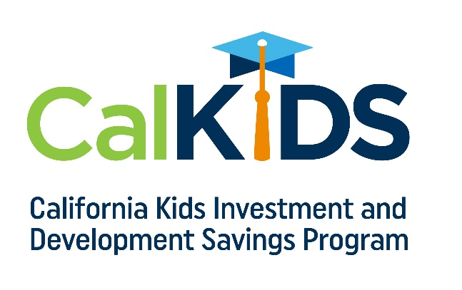

CalKIDS is the long-awaited children’s savings account program that offers all newborns and eligible low-income public school students in California between $25 and $1,500 to start saving for college and career training. Families are encouraged to build on this investment by opening and contributing to a ScholarShare 529 account of their own and see their college savings balances all in one place.

The program provides the following incentives:

Up to $1,500 for 3.4 Million School-Age Children:

- $500 Automatic Deposit: Eligible low-income public school students in grades 1-12.
- $500 Additional Deposit: Eligible low-income public school students in grades 1-12 identified as foster youth.
- $500 Additional Deposit: Eligible low-income public school students in grades 1-12 identified as homeless.

Up to $100 for Newborn Children:
- $25 Automatic Deposit: Every eligible child born on or after July 1, 2022.
- $25 Additional Deposit: Those who register on the program’s online portal.
- $50 Additional Deposit: Those who link a new or existing ScholarShare 529 account to the CalKIDS account.

Visit www.calkids.org today to learn more about eligibility, registering for the program, and getting started on your savings!

