Saving Versus Borrowing
Understanding the long-term financial realities of borrowing.

Using both loans and savings to pay for your child’s college is a common strategy, but there are factors you’ll want to consider when measuring the importance of college savings against other competing financial priorities—including the impact of debt your child’s lifetime earning potential and how saving versus borrowing stacks up dollar for dollar.

Saving now or borrowing later
When it comes to how you pay for school, it’s better to save now than borrow later. When you’re saving, interest and investment earnings can work for you. When you’re borrowing, interest can work against you. In the same way that compounding interest or earnings over a long period of time can significantly increase your savings, repaying interest on a loan over a long period of time can significantly increase your debt.

Depending upon the interest rate and repayment terms, you can pay as much or more in interest than the original loan itself. And the fact that student loans can impact an individual’s lifetime wealth, saving more now just makes smart financial sense.

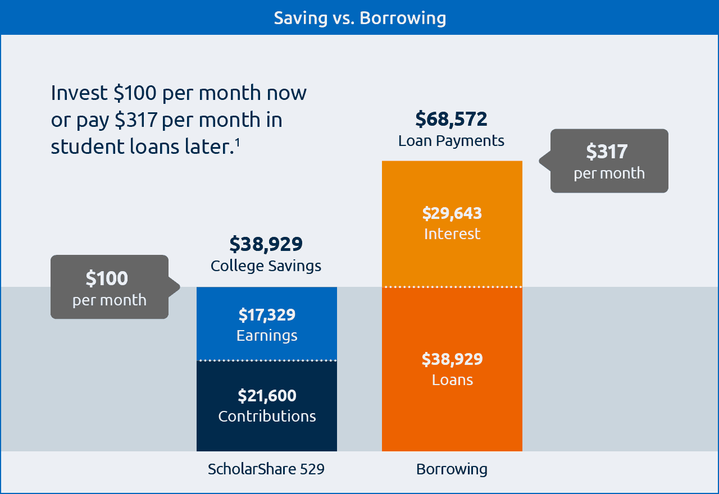

¹The ScholarShare 529 example assumes a 6% rate of return compounded monthly for an 18-year period. The final account balance does not reflect taxes or penalties that might be due upon distribution. The borrowing example reflects a 7% interest rate compounded monthly for an 18-year period. The calculations are for illustrative purposes only and the results are not indicative of any loan product or the performance of any investment.

Make saving easier
Here are a few tips and tricks that can make saving for your child’s education worry free.

- Save small amounts weekly or monthly.
Don’t try to save huge amounts that will adversely impact your available income. Just save a small amount and invest it steadily. It’s not about trying to cover the entire cost of your child's education—it’s about saving as much as you can within your means.

- Set up recurring contributions.
A good way to help your account grow is to make sure it’s a normal part of your monthly bills. Recurring contributions make payments easy and predictable, so it becomes a regular, expected expenditure within your monthly budget.

- Set up direct deposit from your paycheck.
If you’re like most people, when your contribution is automatically deducted from your paycheck, you'll hardly notice the difference. In the meantime, your account can be quietly growing year after year. This is a great, stress-free way to help build your account.

- Use your tax refunds or other annual lump sums such as a bonus or inheritance.
While investing small and steady amounts can help build your account at a regular pace, occasional lump sums like a tax refunds or other financial windfall is a great way to leap forward. Adding just one lump sum a year in addition to normal payments can make a big difference in how fast your account potentially grows.

- Invite friends and family to make gift contributions.
Friends, grandparents, aunts and uncles all want to see your child succeed. Let them know about the account and how easy it is to make a gift contribution. Chances are they’ll want to help—even more so once they learn that giving can reduce the taxable income on their estate.

- Get your kids to participate.
Does your son or daughter have an allowance, stipend or part-time job? Encourage them to invest a portion of that money in their college savings account. Helping to pay for their own education nurtures a greater appreciation for money and helps build a sense of fiscal responsibility early in life.

Remember, it’s not about covering all the costs for your child’s college—it’s about saving as much as you can, when you can.

Kickstart your college savings
The state of California is committed to helping children thrive, particularly by increasing access to higher education. To that aim, CalKIDS will provide each child born in California on or after July 1, 2022, as well as eligible low-income public-school students enrolled in first through 12th grade, with a seed deposit and possible financial incentives in a 529 college savings account.

Children with $500 or less designated for college savings are 3x more likely to enroll in college and nearly 4X more likely to graduate than children with no savings. So, let CalKIDS kickstart your child’s college savings…

Visit the CalKIDS site to learn more.

The California Kids Investment and Development Savings Program (CalKIDS) is a children’s savings account program, administered by the ScholarShare Investment Board, an agency of the State of California. CalKIDS accounts will be established for children born to California families and eligible public school students, and will include seed deposits and other potential incentives, which can be used to pay for future higher education expenses.

CalKIDS participants may also establish individual accounts with the ScholarShare College Savings Plan.
For more information about the ScholarShare College Savings Plan, call 1-800-544-5248 or click here for a Plan Description which includes investment objectives, risks, charges, expenses, and other important information. Read and consider it carefully before investing.

Before you invest, consider whether your or the beneficiary’s home state offers any state tax or other state benefits such as financial aid, scholarship funds, and protection from creditors that are only available for investments in that state’s qualified tuition program. You should also consult your legal or tax professional for tax advice based on your own circumstances. Investments in the plan are neither insured nor guaranteed and there is the risk of investment loss.

If the funds aren’t used for qualified higher education expenses, a 10% penalty tax on earnings (as well as federal and state income taxes) may apply. Non-qualified withdrawals may also be subject to an additional 2.5% California tax on earnings.

The ScholarShare College Savings Plan is offered by the State of California. TIAA-CREF Tuition Financing, Inc. (TFI), program manager. TIAA-CREF Individual & Institutional Services, LLC, Member FINRA, distributor and underwriter for the ScholarShare College Savings Plan.

The Plan Web site contains links to other Web sites. Neither the Plan nor TFI and its affiliates are responsible for the content of those other Web sites. The accuracy of information on those sites cannot be confirmed. 2230999

